HUMAN LIFE DETECTION DURING FIRE (YOLOV8 and V9)
Ms. MONISHA GUPTA¹,SUNKU SAI YASWANTH², GAJJALA AKHILA³, K PAVAN KUMAR⁴
¹AssistantProfessor in Department of Computer Science and Engineering & Presidency University, Bengaluru
² Student in Computer Science and Engineering & Presidency University, Bengaluru
³ Student in Computer Science and Engineering & Presidency University, Bengaluru
⁴ Student in Computer Science and Engineering & Presidency University, Bengaluru
---------------------------------------------------------------------***----------------------------------------------------------
Abstract -This project focuses on designing and evaluating an advanced detection system capable of identifying humans, fire, and smoke in real-time. Using cutting-edge deep learning algorithms such as YOLOv8 and YOLOv9, the system will analyse and classify these elements accurately in both uploaded images and live camera feeds. The project leverages a diverse dataset from Roboflow, featuring images of humans, fire, and smoke, to train and validate the models.
Development will take place in Python, utilizing Google Colab as the primary development environment. The system will be designed to work with images captured from a laptop camera, though potential challenges related to resolution and image clarity may impact detection performance. A key part of this study will involve comparing YOLOv8 and YOLOv9 to assess their effectiveness in terms of accuracy, processing speed, and reliability across different scenarios.
The ultimate goal is to create a real-time application that provides alerts and visual feedback when detecting fire, smoke, or human presence. This capability has the potential to significantly improve safety and response measures in critical situations. Through this project, we aim to make a meaningful contribution to the field of computer vision, particularly in the development of systems for safety and security.
Key Words: Real-time detection system, humans, fire, smoke, YOLOv8, YOLOv9, deep learning, Roboflow dataset, image classification, live camera feeds, Python, Google Colab, accuracy, speed, safety, security, computer vision.

1.INTRODUCTION

In recent years, advancements in technology have revolutionized safety and surveillance systems, enabling innovative methods to monitor environments prone to critical hazards. This project aims to develop a real-time detection system that leverages the latest deep learning algorithms, YOLOv8 and YOLOv9, to identify the presence of humans, fire, and smoke. Designed to provide instant visual and auditory alerts, this system offers a reliable solution for enhancing safety in settings where fire or unauthorized human activity could pose significant risks. The system is trained on a diverse dataset from Roboflow, which contains a wide range of images featuring fire, smoke, and human elements, ensuring high accuracy across different scenarios and conditions.
The system is implemented using Python and developed on Google Colab, a cloud-based platform that facilitates efficient model training and testing. By integrating with laptop cameras and standard video feeds, the system is capable of analyzing real-time data, though it also accommodates pre-uploaded images. This flexibility ensures its applicability in various environments, including industrial sites, residential areas, public spaces, and forests. Furthermore, the project involves a comparative analysis of YOLOv8 and YOLOv9, focusing on their performance in terms of accuracy, speed, and robustness in diverse conditions.
Traditional methods for fire and smoke detection, such as smoke alarms, thermal sensors, and human monitoring, often have limitations. Smoke alarms, for instance, are susceptible to false positives caused by dust or steam, while human surveillance is labour-intensive and prone to errors. This project addresses these shortcomings by utilizing YOLO (You Only Look Once), a state-of-the-art object detection framework known for its high-speed and accurate performance. YOLOv8 and YOLOv9, the latest iterations, feature advanced architectures optimized for real-time applications, making them well-suited for this detection system. YOLOv9, in particular, introduces enhancements like attention mechanisms, adaptive image resizing, and an improved path aggregation network, which collectively boost its ability to identify objects in complex or low-quality visuals.
The core objective of this project is to create a highly responsive detection system that excels in both accuracy and versatility. By processing live feeds and static images, the system can adapt to a variety of operational contexts. A meticulously curated and augmented Roboflow dataset enhances the training process, exposing the models to different lighting conditions, angles, scales, and complex scenes. This comprehensive approach ensures the system can accurately detect and differentiate between fire, smoke, and humans, even in challenging environments.
One of the standout features of YOLOv8 and YOLOv9 is their real-time processing capability, which is critical in safety-related applications. These models are built on unified deep learning architectures optimized for speed, allowing them to quickly analyse visual data and trigger alerts without delay. For instance, YOLOv9's advanced features enable it to detect small or fast-moving objects, such as flames, with precision, making it a valuable tool for rapid response scenarios.
Developing the system on Google Colab offers significant advantages, including access to high-performance GPUs for faster training and a collaborative environment for ongoing updates and experimentation. The project uses Python, a versatile language equipped with powerful libraries like TensorFlow, PyTorch, and OpenCV, which streamline the development process. This infrastructure not only ensures efficient model training but also provides a foundation for future enhancements, such as incorporating additional hazard detection or optimizing the system for different hardware platforms.
In practical applications, the system delivers real-time alerts, which are critical for preventing accidents and responding to emergencies. For example, in industrial settings, it can notify staff about fire or unauthorized entry, enabling swift intervention. In outdoor environments, such as forests, the system can detect early signs of smoke, facilitating proactive firefighting efforts and minimizing damage. Beyond immediate benefits, the project contributes to the field of computer vision by offering insights into the performance of YOLOv8 and YOLOv9 in high-stakes scenarios, paving the way for further advancements in safety and security technology.
The anticipated outcome is a fully functional application that enhances situational awareness and response capabilities. By accurately detecting fire, smoke, and human presence, the system supports data-driven decision-making in critical situations, ultimately helping to save lives and reduce risks. This project also lays the groundwork for future innovations, such as integrating the system with drones or IoT devices for remote monitoring in inaccessible areas or extending its capabilities to detect additional hazards.

2. LITERATURE SURVEY

A Fire Prevention/Monitoring Smart System, in this paper the authors propose a smart fire prevention and monitoring system designed to detect potential fire hazards before they escalate. This system leverages IoT devices and sensors to continuously monitor environmental conditions, providing real-time data for fire prevention and early detection. The study highlights the importance of integrating intelligent technologies into fire safety systems to enhance response times and reduce fire-related risks.

Analysis of a Real-Time Fire Detection and Intimation System,
This research focuses on developing a real-time fire detection and alerting system that aims to reduce response times to fire incidents. The authors utilize image processing techniques and sensor data to detect fire and immediately notify relevant personnel. The study underscores the potential of real-time systems in mitigating fire hazards by providing instant alerts, which can play a crucial role in early fire control.

Wireless Fire Detection Monitoring System for Fire and Rescue Application, in this paper the authors present a wireless fire detection monitoring system aimed at improving fire response and rescue operations. This system incorporates wireless communication and sensor networks to provide real-time fire status updates to emergency services. By enabling remote monitoring and faster information relay, this study demonstrates how wireless technology can enhance the efficiency of fire rescue operations.

Research on Fire Detection Based on YOLOv5, in this paper Luo explores the application of the YOLOv5 deep learning model for fire detection, demonstrating its effectiveness in accurately identifying fire in various environmental conditions. The study shows that YOLOv5’s high-speed processing and object detection capabilities make it a suitable choice for real-time fire detection. This research contributes to the growing field of AI-based fire detection, highlighting YOLOv5's potential in providing fast and reliable fire monitoring solutions.

3. PROPOSED METHOD

The proposed system aims to enhance fire, smoke, and human detection by implementing advanced deep learning algorithms, specifically YOLOv8 and YOLOv9, for real-time analysis. Unlike traditional systems, this solution will utilize a comprehensive dataset to train the models for improved accuracy and responsiveness. The system will facilitate both image uploads and live camera feeds, allowing for immediate detection and alerting. By leveraging the strengths of YOLO architectures, the proposed system seeks to minimize false positives and enhance detection capabilities in diverse environments. This innovative approach will significantly improve safety measures and emergency response times in critical situations.

3.1 Advantages of the Proposed System
The proposed system offers several advantages:
- Enhanced Detection Accuracy: By utilizing advanced YOLOv8 and YOLOv9 models, the system improves the detection accuracy for humans, fire, and smoke in diverse environments.
- Real-Time Analysis: The system processes both image uploads and live camera feeds in real-time, enabling immediate detection and alerting, which enhances response times in emergencies.
- Reduced False Positives: The advanced YOLO architectures are designed to minimize false positives, ensuring reliable detection and reducing unnecessary alerts.
- Scalability: The system can be applied across various domains, from industrial safety to public security, providing a flexible solution.
- Robustness in Diverse Conditions: Trained on a comprehensive dataset, the system can perform well in challenging scenarios, such as poor lighting or low-resolution images.

  - Project Work Flow

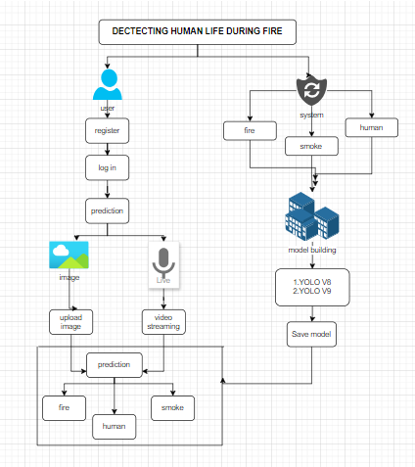

4.METHODOLOGIES

4.1 YoloV8 Architecture Details

Each of these components plays a unique role in processing images and extracting critical information for accurate object detection. Here’s a breakdown of each:
a) Backbone – CSPDarknet
The backbone of YOLOv8 is a customized version of CSPDarknet, which functions as a feature extractor. This backbone leverages Cross Stage Partial Networks (CSPNet) technology to enhance feature extraction efficiency while reducing the model's computational load. In CSPDarknet, the input image undergoes a series of convolutional, batch normalization, and activation layers, which progressively distill image features, capturing low-level details (like edges) in early layers and more complex, high-level features (such as shapes and textures) in later layers.
The CSPNet structure is vital because it divides feature maps into two parts, with only one part processed through residual blocks before merging the two. This split reduces redundant computations, making the model both efficient and effective in handling large feature maps. YOLOv8’s backbone is thus capable of processing input images with greater computational efficiency while maintaining strong feature representation.
b) Neck – PANet (Path Aggregation Network)
The neck of YOLOv8 is a Path Aggregation Network (PANet), designed to enhance feature fusion across multiple scales. The PANet structure integrates both top-down and bottom-up pathways, enabling features from different depths in the backbone to be combined. This design enriches the model’s ability to detect objects of varying sizes, ensuring that small details are not overlooked while capturing the larger context of the scene.
PANet helps strengthen both object localization and classification by aggregating fine-grained details with broader contextual information. This multiscale feature fusion is crucial for applications that require precise detection of small objects, like a distant human in a safety surveillance scenario or small flames and smoke in fire detection.
c) Detection Head – Anchor-Free YOLO Head
The detection head in YOLOv8 is responsible for generating bounding boxes, class probabilities, and confidence scores for each detected object. Unlike traditional YOLO heads, YOLOv8 uses an anchor-free design, which simplifies the model and reduces computational requirements. This anchor-free approach predicts the location, size, and classification of objects directly without relying on predefined anchor boxes, making YOLOv8 easier to configure and more versatile across different use cases.
The detection head operates at three different scales, allowing YOLOv8 to accurately capture objects of various sizes. This multiscale approach is crucial for scenarios where the objects range from small (e.g., flames or tiny smoke clouds) to large (e.g., a person). Each scale outputs a matrix that includes coordinates, class labels, and confidence scores for each detected object.
d) Loss Function
YOLOv8 employs a combination of loss functions to optimize model performance:
- CIoU Loss (Complete Intersection over Union): Enhances the alignment between predicted and ground truth bounding boxes by considering overlap, distance, and aspect ratio. This function helps improve localization accuracy.
- Classification Loss: Penalizes errors in the classification of detected objects, ensuring high accuracy in object identification.
- Objectness Loss: Focuses the model’s attention on regions that likely contain objects, reducing false positives and making predictions more reliable.

4.2 YoloV9 Architecture Details

Each component in YOLOv9’s architecture contributes to efficient processing and accurate object detection. Here’s a breakdown of each:
a) Backbone – CSPDarknet++ with Enhanced Attention Mechanisms
YOLOv9 uses an improved version of CSPDarknet called CSPDarknet++. This backbone incorporates an advanced attention mechanism, which allows the model to focus on significant parts of the image, reducing interference from background noise and enhancing the model’s ability to differentiate between objects. The CSP (Cross Stage Partial) structure, central to CSPDarknet++, splits feature maps into two streams: one is processed through residual blocks, while the other bypasses these blocks and is combined afterward. This structure reduces redundant computations and enhances feature extraction, making the model both efficient and accurate.
The backbone also includes a Self-Attention Module that learns to highlight important areas in an image, making YOLOv9 especially effective in detecting objects in cluttered scenes, such as fire and smoke within complex backgrounds. Additionally, CSPDarknet++ uses a combination of convolutional and activation layers (typically Mish or Swish) to extract deep, high-level features essential for object classification.
b) Neck – Enhanced PANet with Adaptive Feature Pyramid Network (AFPN)
The neck in YOLOv9 is an enhanced PANet with an added Adaptive Feature Pyramid Network (AFPN) component. This network improves multiscale feature fusion, allowing YOLOv9 to handle objects at varying scales more effectively. The AFPN structure uses a top-down and bottom-up approach, combining features across multiple layers. AFPN adjusts feature maps dynamically to ensure better detection for objects of different sizes by weighing the importance of specific layers based on object scale.
The multiscale fusion provided by this neck enables the model to accurately detect both large and small objects, making it particularly suitable for detecting distant flames, small patches of smoke, or people in real-time safety applications. This flexibility enhances the model's adaptability, allowing it to perform well even when objects occupy only a small part of the image.
c) Detection Head – Dual-Path YOLO Head with Attention
YOLOv9’s detection head is more advanced than its predecessors, featuring a dual-path architecture with integrated attention mechanisms. This dual-path design allows the model to predict bounding boxes and classify objects through two parallel paths, improving detection speed and accuracy. The addition of Spatial Attention Modules ensures that the model focuses on relevant areas of the image, enhancing its ability to detect objects in challenging conditions, such as low-light environments or low-resolution video feeds.
This anchor-free detection head also uses three scales to predict object locations, sizes, and classes, covering small, medium, and large objects in a scene. The anchor-free design simplifies the model, allowing it to achieve faster processing speeds while maintaining high accuracy across different object sizes and types.
d) Loss Function
YOLOv9 optimizes object detection using a sophisticated combination of loss functions, which include:
- CIoU Loss (Complete Intersection over Union): A robust metric that accounts for overlap, distance, and aspect ratio between predicted and ground truth boxes, optimizing localization.
- Classification Loss: Penalizes classification errors, encouraging precise labelling of objects.
- Objectness Loss: Guides the model to focus on regions containing objects, reducing false positives in object-free areas.

5.RESULT

The page allows you to either start a live video feed for human detection or upload an image for analysis. The goal is to identify human figures in real-time or static images.
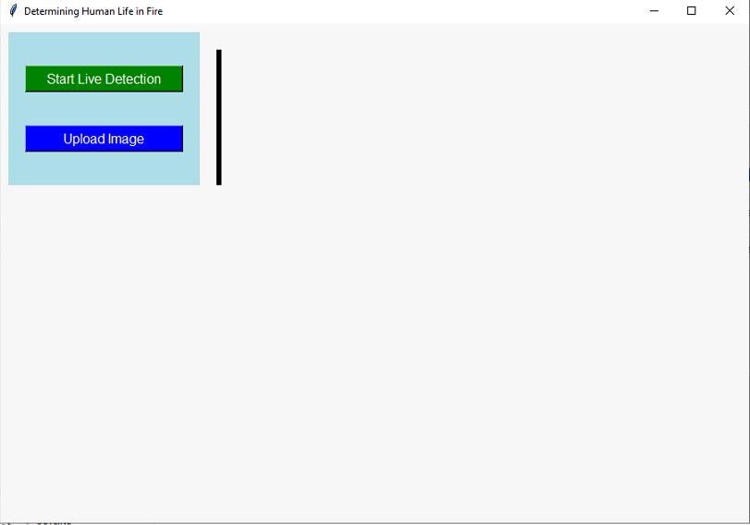

Upload Page:
Upload an image of a fire scene. Our tool will analyze the image and detect any humans present within the fire, providing visual cues for potential rescue efforts.

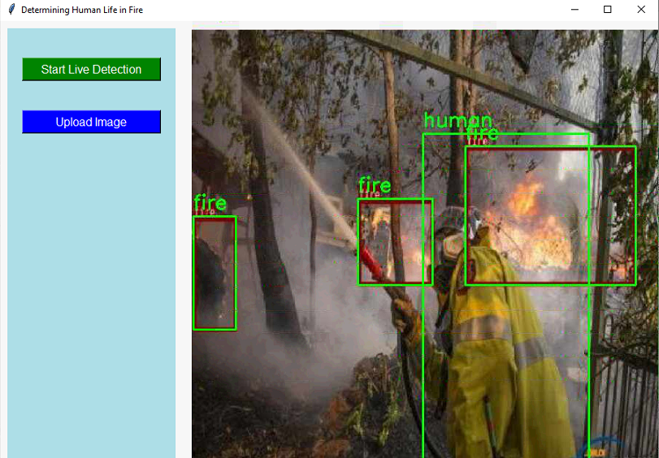

Live Detection Page:
The page is likely part of a fire detection or surveillance system. It displays a live video feed with a green rectangle highlighting a potential human figure within a fire and smoke.

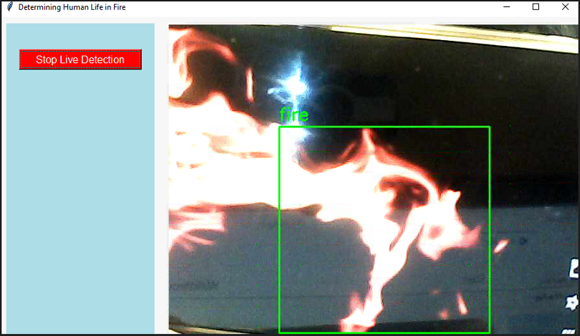

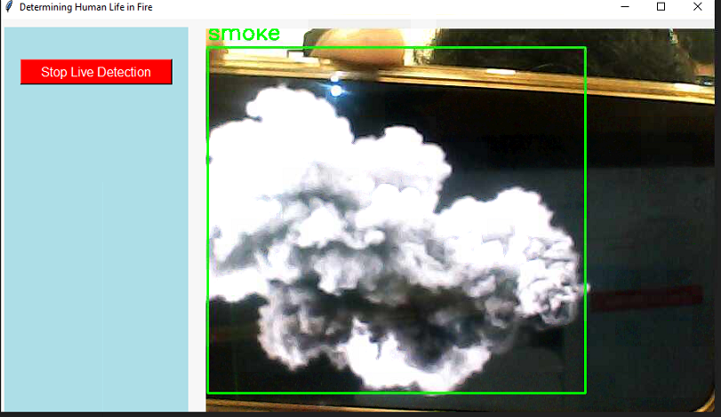

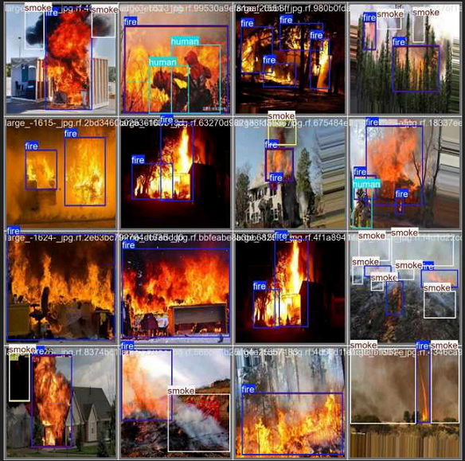

This shows how the model detects fire, smoke, and humans in test images using bounding boxes.
- Fire detection appears accurate and consistent.
- Smoke detection is reasonable but may struggle in complex scenes.
- Human detection is less reliable, likely due to occlusion or challenging conditions.

6.CONCLUSION

YOLOv9 demonstrates outstanding performance in detecting critical classes like "fire" (precision-recall 0.982) and "smoke" (0.855), with minimal misclassifications, making it highly suitable for real-time safety applications such as fire and smoke monitoring. However, it struggles with "human" detection (precision-recall 0.536), leading to misclassifications with other classes like background and smoke. Its overall mAP@0.5 (0.791) is solid but slightly lower than YOLOv8, indicating room for improvement in generalizing across all classes.
YOLOv8, on the other hand, achieves higher mAP scores and delivers more balanced performance across all classes, including better detection of humans. The model shows consistent learning with steadily declining training and validation losses, making it versatile for diverse object detection tasks. While YOLOv8 is better for general-purpose applications, YOLOv9 excels in specific, high-precision scenarios like fire and smoke detection. The choice depends on whether the focus is on specific safety-critical tasks or broader object detection needs.

7. REFERENCES

- Zaher, A., Al-Faqsh, A., Abdulredha, H., Al-Qudaihi, H., & Toaube, M. (2021). A Fire Prevention/Monitoring Smart System. 2021 2nd International Conference on Smart Cities, Automation & Intelligent Computing Systems (ICON-SONICS). IEEE.
- Luo, W. (2021). Research on fire detection based on YOLOv5. IEEE.
- Seetharaman, R., Sreeja, R. R., Dakshin, S. Vidhul, Nivetha, N., Gowsigan, S., & Barath, M. (2020). Analysis of a Real Time Fire Detection and Intimation System. IEEE.
- Ahmad Azmil, M. S., Ya'acob, N., Tahar, K. N., & Sarnin, S. S. (2015). Wireless fire detection monitoring system for fire and rescue application. 2015 IEEE 11th International Colloquium on Signal Processing & Its Applications (CSPA). IEEE.

